Hypothesis testing uses sample data to evaluate an assumption about a population parameter. Data professionals conduct a hypothesis test to decide whether the evidence from their sample data supports either the null hypothesis or the alternative hypothesis.

steps for conducting a hypothesis test:
- State the null hypothesis and the alternative hypothesis.
- Choose a significance level.
- Find the p-value.
- Reject or fail to reject the null hypothesis.
The first step for any hypothesis test is to state the null and alternative hypotheses. The null and alternative hypotheses are mutually exclusive, meaning they cannot both be true at the same time.
The null hypothesis is a statement that is assumed to be true unless there is convincing evidence to the contrary. The null hypothesis typically assumes that there is no effect in the population, and that your observed data occurs by chance.
The alternative hypothesis is a statement that contradicts the null hypothesis, and is accepted as true only if there is convincing evidence for it. The alternative hypothesis typically assumes that there is an effect in the population, and that your observed data does not occur by chance.
For example, imagine you’re a data professional working for a car dealership. The company implements a new sales training program for their employees. They ask you to evaluate the effectiveness of the program.
- Your null hypothesis (H₀): the program had no effect on sales revenue.
Null hypotheses often include phrases such as “no effect,” “no difference,” “no relationship,” or “no change.”
The null hypothesis always includes an equality symbol
- Your alternative hypothesis (H_{a}): the program increased sales revenue.
Often include phrases such as “an effect,” “a difference,” “a relationship,” or “a change.”
The alternative hypothesis always includes an inequality symbol (usually ≠, but sometimes < or >).
The null hypothesis assumes that the status quo hasn’t changed. The alternative hypothesis suggests a new possibility or different explanation

Type I and Type II errors.
because hypothesis testing is based on probability, there’s always a chance of drawing the wrong conclusion about the null hypothesis. In hypothesis testing, there are two types of errors you can make when drawing a conclusion: a Type I error and a Type II error.
When you decide to reject or fail to reject the null hypothesis, there are four possible outcomes–two represent correct choices, and two represent errors. You can:
- Reject the null hypothesis when it’s actually true (Type I error) (they conclude the result occurred by chance when it is actually statistically significant).
- Reject the null hypothesis when it’s actually false (Correct)
- Fail to reject the null hypothesis when it’s actually true (Correct)
- Fail to reject the null hypothesis when it’s actually false (Type II error)
The probability of making a Type I error is called alpha (α). Your significance level, or alpha (α), represents the probability of making a Type I error. Typically, the significance level is set at 0.05, or 5%. A significance level of 5% means you are willing to accept a 5% chance you are wrong when you reject the null hypothesis.
To reduce your chance of making a Type I error, choose a lower significance level.
However, reducing your risk of making a Type I error means you are more likely to make a Type II error, or false negative.
You can reduce your risk of making a Type II error by ensuring your test has enough power. In data work, power is usually set at 0.80 or 80%. The higher the statistical power, the lower the probability of making a Type II error. To increase power, you can increase your sample size or your significance level. (beyond course)

One-sample test
A one-sample test determines whether or not a population parameter, like a mean or proportion, is equal to a specific value
z-test
makes the following assumptions:
the data is a random sample of a normally-distributed population,
the population standard deviation is known.
Typically, the mean delivery time for an online food order is 40 minutes with a standard deviation of five minutes. But recently, company management launched a new training program to make the delivery process more efficient. After delivery drivers completed the training program, management tracked a random sample of 50 deliveries to understand how long a delivery takes. The sample of 50 deliveries had a mean delivery time of 38 minutes with a standard deviation of five minutes. There is an observed difference of two minutes between the population mean of 40 minutes and the sample mean of 38 minutes. The management team asks you to determine if the decrease in average delivery time is statistically significant or if it's due to chance. If the decrease is statistically significant, the company wants to invest in developing and implementing the training program in other regions. You decide to conduct a one-sample z-test to analyze the data.
In a one-sample z-test, the null hypothesis states that the population mean is equal to an observed value. In this case, your null hypothesis says that the average delivery time equals 40 minutes, 40 minutes is the standard average delivery time. The alternative hypothesis is a statement that contradicts the null hypothesis
In a one-sample test, there are three main options for the alternative hypothesis: the population mean is not equal to, less than, or greater than an observed value. In this case, you want to test whether the training has decreased the average delivery time.
Next, set the significance level or the threshold at which you will consider our results statistically significant. This is also the probability of rejecting the null hypothesis when it is true. You choose a significance level of five percent, which is the company's standard for data analysis
Now, find the p-value. Recall that your p-value is the probability of observing a difference in your results as or more extreme than the difference observed when the null hypothesis is true.
Typically, the mean delivery time is 40 minutes. The mean delivery time of your sample is 38 minutes. Your null hypothesis claims that this two-minute difference in delivery time is due to chance or sampling variability. Your p-value is the probability of observing a difference that is two minutes or greater if the null hypothesis is true.
If the probability of this outcome is very unlikely, in particular, if your p-value is less than your significance level of five percent, then you'll reject the null hypothesis.
you'll almost always calculate p-value on your computer using a programming language like Python or other statistical software.
The p-value is calculated from what's called a test statistic. In hypothesis testing, the test statistic is a value that shows how closely your observed data matches the distribution expected under the null hypothesis, so if you assume the null hypothesis is true and the mean delivery time is 40 minutes, the data for delivery times follows a normal distribution. The test statistic shows where your observed data, a sample mean delivery time of 38 minutes, will fall on that distribution.
Since you're conducting a z-test, your test statistic is a z-score. Recall that a z-score is a measure of how many standard deviations below or above the population mean a data point is. Z-scores tell you where your values lie on a normal distribution. The following formula gives you a test statistic z based on your sample data

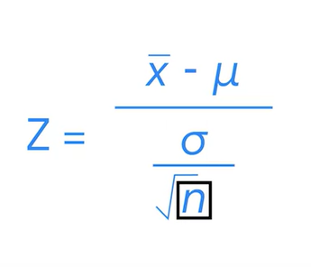
If you enter the numbers in the formula and do the calculation, you get a z-score of -2.82.
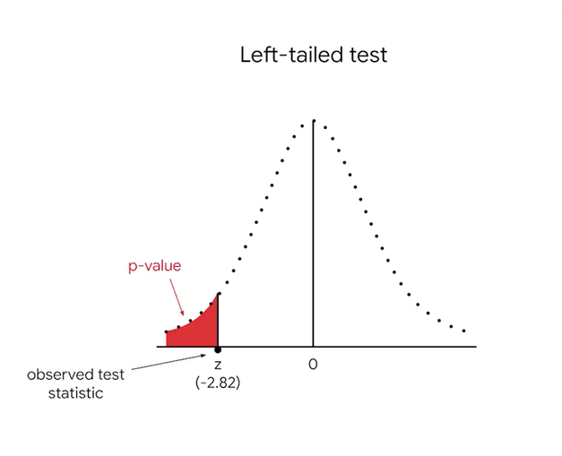
Let's check out where the z-score, negative 2.82, lies on the distribution. It's far to the left, almost three standard deviations below the mean. For a normal distribution, the probability of getting a value less than your z-score of -2.82 is calculated by taking the area under the curve to the left of the z-score. This is called a left-tailed test because your p-value is located on the left tail of the distribution. The area under this part of the curve is the same as your p-value.
Your alternative hypothesis states that the mean delivery time decreased based on your sample data. That's why we're interested in the probability of getting any value lower than your z-score of -2.82.
If you calculate the p-value, you'll find that it's 0.0023, so your p-value is 0.0023 or 0.23 percent. This means there's a 0.23 percent probability that the difference in mean delivery time would be 2 minutes or greater if the null hypothesis is true. In other words, it's highly unlikely that their difference is due to chance.
To draw a conclusion about your null hypothesis, compare your p-value with the significance level. If your p-value is less than the significance level, you conclude that there is a statistically significant difference in mean delivery time. In other words, you reject the null hypothesis. If your p-value is greater than the significance level, you conclude that there is not a statistically significant difference in mean delivery time.
Your results suggest that the faster delivery time is likely due to the positive effects of the training. Your analysis will help company leadership decide whether to make a bigger investment in the training program going forward. Based on your results, they're likely to do so.
Note: 5% is a conventional choice, and not a magical number. It’s based on tradition in statistical research and education. Other common choices are 1% and 10%. You can adjust the significance level to meet the specific requirements of your analysis. A lower significance level means an effect has to be larger to be considered statistically significant.
There are two main rules for drawing a conclusion about a hypothesis test:
- If your p-value is less than your significance level, you reject the null hypothesis.
- If your p-value is greater than your significance level, you fail to reject the null hypothesis.
Note: Data professionals and statisticians always say “fail to reject” rather than “accept.” This is because hypothesis tests are based on probability, not certainty—acceptance implies certainty. In general, data professionals avoid claiming certainty about results based on statistical methods.

We also talked about two-saple test, in which the value is 2 time the p value used for one-sample tets. Meaning both sides of the curve. Also the example does is using the t-distribution formula instead (for less than 30 samples)

A two-sample hypothesis test determines whether two population parameters, such as two means or two proportions, are equal. A one-sample hypothesis test determines whether a population parameter, such as a mean or proportion, is equal to a specific value.

In a two-sample t-test, the null hypothesis states that there is no difference between two population means. T-tests do not apply to proportions. Use a two-sample z-test to compare two population proportions.
Experimental Design
refers to planning an experiment in order to collect data to answer your research question.
There are at least three key steps in designing an experiment:
- Define your variables
- The independent variable refers to the cause you’re interested in investigating. A researcher changes or controls the independent variable to determine how it affects the dependent variable. “Independent” means it’s not influenced by other variables in the experiment.
- The dependent variable refers to the effect you’re interested in measuring. “Dependent” means its value is influenced by the independent variable.
- Formulate your hypothesis
- Assign test subjects to treatment and control groups
Experiments such as clinical trials and A/B tests are controlled experiments. In a controlled experiment, test subjects are assigned to a treatment group and a control group. The treatment is the new change being tested in the experiment. The treatment group is exposed to the treatment. The control group is not exposed to the treatment. The difference in metric values between the two groups measures the treatment’s effect on the test subjects.
In a completely randomized design, test subjects are assigned to treatment and control groups using a random process. For example, in a clinical trial, you might use a computer program to label each subject with a number and then randomly select numbers for each group.
Sometimes, however, a completely randomized design might not be the most effective approach. When designing an experiment, data professionals must account for nuisance factors. These are factors that can affect the result of an experiment, but are not of primary interest to the researcher.
Researchers can use a randomized block design to minimize the impact of known nuisance factors. Blocking is the arranging of test subjects in groups, or blocks, that are similar to one another. In a block design, you first divide subjects into blocks, and then you randomly assign the subjects within each block to treatment and control groups.

